**DIRECT CURRENT**

* ***Kirchhoff’s Laws (KL)***
  + ***Kirchhoff Current Law***
 $$\sum_{k∈(node)}{±I_{k}}=0$$

 $$\sum_{k∈(node-in)}{+I_{k}}=\sum_{k∈(node-out)}{+I_{k}}$$

+ ***Kirchhoff Voltage Law***
$$\sum_{k∈(loop)}{±U_{k}}=0$$

$$\sum_{k∈(loop)}{±E_{k}}=\sum_{k∈(loop)}{±I_{k}∙R_{k}}+\sum_{k∈(loop)}{±U_{gk}}$$

* ***Power DC***
$$\sum_{k∈(Active)}{P_{k}}=\sum_{k∈(Passive)}{P_{k}}$$

$$\sum_{k∈(A)}{U_{k}∙I_{k}}=\sum_{k∈(P)}{U_{k}∙I_{k}}$$

* ***Real Sources***
  + ***Real Voltage Source***
 $$E and r \left(internal resistance\right)-series$$

 $$I=\frac{E}{r+R}$$

$$U=I∙R=\frac{R}{r+R}∙E$$

$$U=E-r∙I$$

+ ***Real Current Source***
 $$E and r \left(internal resistance\right)-parallel :r≫R$$

 $$I=\frac{E}{r+R}≅\frac{E}{r}$$

$$I=I_{S}-I_{r}=I_{S}-\frac{U}{r}$$

$$U=I∙R=I_{r}∙r$$

$$I=\frac{r}{R+r}∙I_{S}$$

+ ***Source Transformation***
$$E and R-series ⇔I_{S} and R-parallel$$

$$E=I_{S}∙R$$

* ***Linearity & Superposition***
  + ***More Sources – ex. $S_{1}(E-VS) \& S_{2}(I_{S}-CS)$***
 $$I=I_{1}+I_{2}$$

 $$\left\{\begin{aligned}I_{1}=I|_{S_{1}=off} \\ I_{2}=I|_{S_{2}=off}\end{aligned}\right.⇔\left\{\begin{aligned}I_{1}=I|_{E=0-short circuit} \\ I_{2}=I|_{I_{S}=0-open circuit}\end{aligned}\right.$$

+ ***Generalized***
$$y_{i}=y|_{x_{k}=0}, k=\overline{1,n} and k≠i$$

* ***Source Transportation***
  + ***Voltage Source***
 $$- node:connecting same voltage source \left(E\right) same direction, on all branches leading to node$$

 + ***Current Sources***
$$- loop: connecting same current source \left(I_{S}\right) same direction, on all branches in the loop$$

* ***Thevenin & Norton Theorems***
  + ***Thevenin***

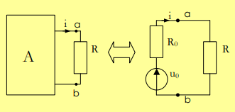

* + ***Norton***

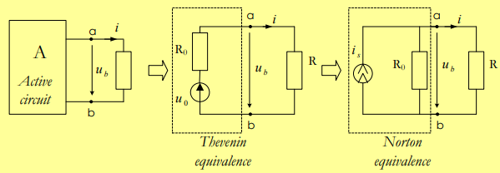

$$U_{b}=\frac{I_{sc}}{G+G_{0}}$$

$$- CALCULATING R_{0}:$$

$$- Replace: -Voltage Source →Closed/Short Circuit$$

$$-Current Source→Open Circuit$$

$$-Calculate R_{eq}=R_{0}$$

$$- CALCULATING U_{0}:$$

$$-Making a short circuit between a \& b anc calculating the current$$

$$*ALTERNATE METHOD: Thevenien →Source Transformation$$

* ***Mesh Analysis***
  + ***Node Analysis ex. 3 nodes***
 $$- Set reference node/GND (ex.{ V}_{3} = 0V)$$

 $$- Calculate Voltage Differences: \left\{\begin{aligned}U_{31}=V_{1}-0=… \\ U_{21}=V_{1}-V_{2}=… \\ U_{32}=V_{2}-0=…\end{aligned}\right.⇔\left\{\begin{aligned}U_{ij}=V_{j}-V_{i}=…, i,j∈\left(nodes\right), i≠j \\ …\end{aligned}\right.$$

$$- Calculate Currents: \left\{\begin{aligned}I_{i}=…, i∈(currents) \\ …\end{aligned}\right.$$

$$-Calculate KCL for node j:\left\{\begin{aligned}\sum_{i∈(node j)}{{±I}_{i}=0} \\ …\end{aligned}\right.$$

$$- Replace KCL currents with calculated currents$$

$$- Solve for voltage in each node$$

+ ***Loop Analysis ex. 3 loops***
$$- Set loop currents \left(ex. I_{11},I_{22},I_{33}\right) \& direction$$

$$- Calculate Currents: \left\{\begin{aligned}I_{i}=\sum_{j∈(loops near current)}{{±I}_{jj}}, i∈(currents) \\ …\end{aligned}\right.$$

$$-Calculate KVL for loop j:\left\{\begin{aligned}\sum_{i∈(loop j)}{{±I}_{i}∙R_{i}}=\sum_{i∈(loop j)}{{±E}_{i}} \\ …\end{aligned}\right.$$

$$- Replace KVL currents with calculated currents$$

$$- Solve for currents in each loop$$

* ***Maximum Power Transfer***

$$I=\frac{U_{0}}{R+R_{0}}$$

$$P_{R}=I^{2}∙R=\frac{R}{{(R+R_{0})}^{2}}∙U_{0}^{2}$$

$$⇒R^{*}=R_{0}$$

$$P_{R}^{max}=\frac{U_{0}^{2}}{4∙R^{*}}$$